# CS 255 System Document

## UML Diagrams

### UML Use Case Diagram

*[In Module Six, you were asked to complete a use case diagram based on your system design. If you would like to make any adjustments to your diagram, please do so. Please insert your use case diagram here. Check to make sure that you included appropriate components and symbols and that your design meets the client’s needs.]* *A computer screen shot of a diagram
*

### UML Activity Diagrams

*[You were asked to choose* ***two*** *use cases and create* ***two*** *activity diagrams, one for each use case. Please insert* ***both*** *of your activity diagrams here. Check to make sure that you included appropriate components and symbols and that your design meets the client’s needs.]*

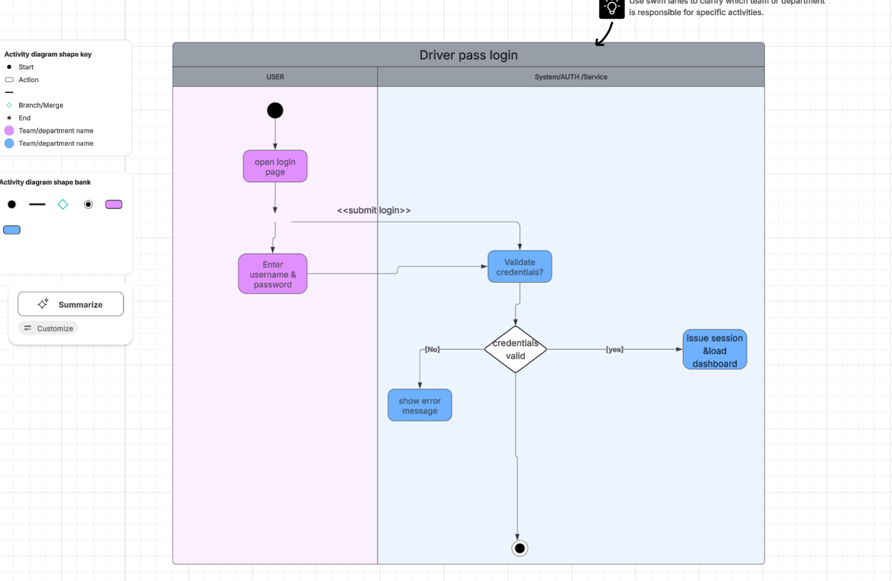

2

### UML Sequence Diagram

*[You were asked to create a sequence diagram based on* ***one*** *of the use cases you chose. Please insert your sequence diagram here. Check to make sure that you included appropriate components and symbols and that your design meets the client’s needs.]*

### UML Class Diagram

## Technical Requirements

## ****System Requirements****

### ****Hardware Requirements for Host****

* At least one dedicated **server or cloud instance** capable of hosting DriverPass web services
* **Networking cables** or cloud network connection for data transfer
* **Monitor, keyboard, and mouse** for system maintenance and configuration
* **Power supply** and UPS (uninterruptible power source)
* **Reliable internet provider** for remote client access

### ****Hardware Requirements for Client****

* Desktop or laptop computer (Windows, macOS, or Linux)
* **Wi-Fi router** or **Ethernet connection** for internet access
* Power supply or laptop battery
* Stable **internet connection** for logging in and scheduling lessons

### ****Software Requirements for Host****

* **Operating System:** Windows Server or Linux (Ubuntu/CentOS)
* **Application Software:** DriverPass web application and supporting APIs
* **Database Software:** MySQL or PostgreSQL for storing user, lesson, and vehicle data
* **Security Software:** Firewall and antivirus to protect sensitive client information
* **Containerization / Deployment Tools:** Docker and Virtual Machine management tools for scalability

### ****Software Requirements for Client****

* **Web browser** (Google Chrome, Firefox, Safari, or Edge)
* **Operating system** (Windows, macOS, Linux, or ChromeOS)
* **Security software** for protecting user credentials during login
* **Email client or mobile app** to receive system notifications and lesson reminders

### ****Tools Required for Development****

* **Programming IDEs:** Eclipse, Visual Studio Code, or IntelliJ IDEA
* **Languages & Frameworks:** Java, Python, HTML/CSS, JavaScript, and Flask or Spring Boot
* **Version Control:** GitHub for source code collaboration
* **Testing Tools:** Postman for API testing and JUnit for unit testing
* **Internet connection** for repository sync and cloud deployment

### ****Infrastructure Required****

* **Cloud hosting service** (AWS, Azure, or Google Cloud) for deploying the DriverPass system
* **Database server** for managing student, instructor, and lesson data
* **Monitoring tools** (e.g., AWS CloudWatch or Nagios) to track uptime and network performance
* **Backup storage** to ensure recovery of user and lesson information in case of failure